**Data Analysis Competency 2 - Summative Assessment**

Basic Monthly Budget for Medical Office

*You will need to do*wnload this attachment to complete this summative:

[PR1-Data](https://assets.learnosity.com/organisations/849/f88068ed-5a4f-42f3-bbf4-98e77ba3eb25.xlsx)

**Creating and maintaining budgets are common practices in many careers. Budgets play a critical role in helping a business or household control expenditures. In this exercise, you will create a budget for a hypothetical medical office while reviewing the skills covered in this chapter.**

1. Open the file name PR1 Data, then Save As PR1 Medical Office Budget.
2. Activate all the cell locations in the Sheet1 worksheet by left clicking the Select All button in the upper left corner of the worksheet.

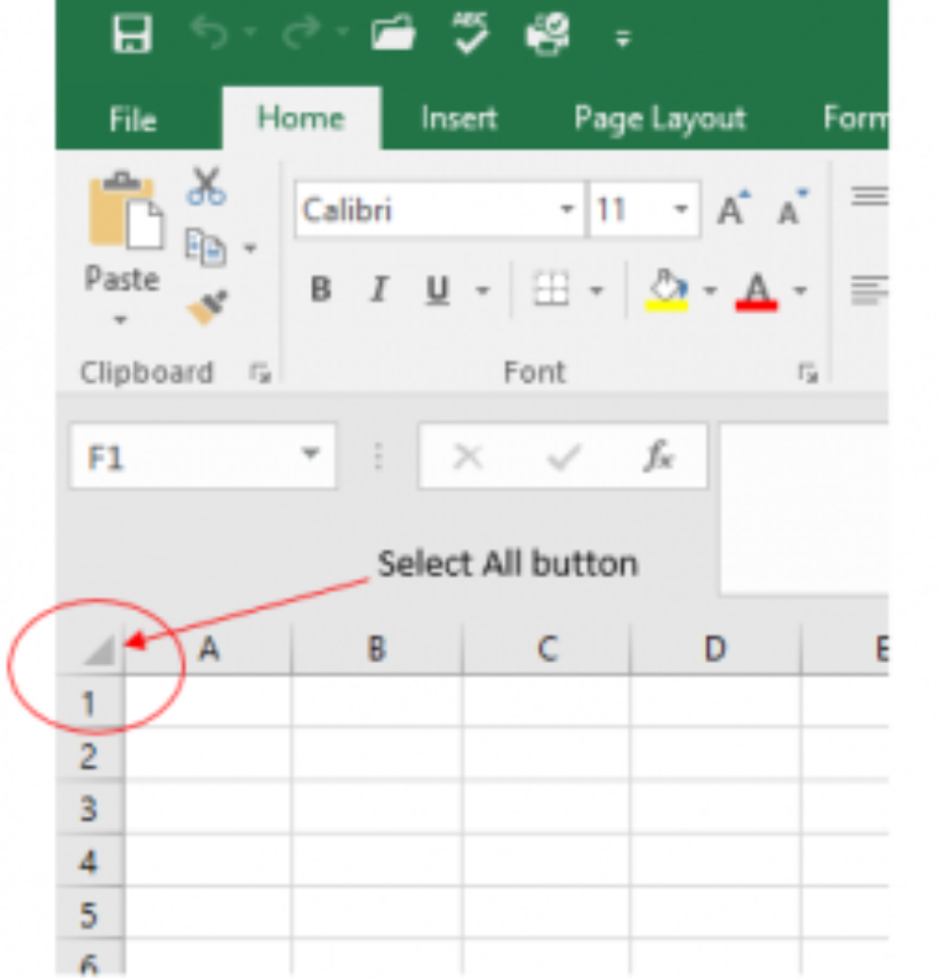

1. In the Home tab of the Ribbon, set the font style to Arial and the font size to 12 points. Then click any cell to Deselect.
2. **Increase the width of Column A so all the entries in the range A3:A8 are visible. Place the mouse pointer between the letter A and letter B of Column A and Column B.**
3. Enter Quarter 1 in cell B2.
4. **Use AutoFill to complete the headings in the range C2:E2. Activate cell B2 and place the mouse pointer over the Fill Handle. When the mouse pointer changes to a black plus sign, left click and drag it to cell E2.**
5. Enter the words Medical Office Budget in cell A1.
6. **Insert a blank column between Columns A and B by clicking on any cell in Column B. Then, click the drop-down arrow of the Insert button in the Home tab of the Ribbon. Click the Insert Sheet Columns option.**
7. Enter the words Budget Cost in cell B2.
8. **Highlight the range A1:F1 and click the Merge button in the Home tab of the Ribbon to merge the cells in that range. Then, click More Options next to the Merge function, find the align function, then select the center alignment option.**
9. **Make the following format adjustments to the range A1:F1: bold; italics; change the font size to 14 points; change the cell fill color any color you prefer and change the font color to white, if it is visually appealing.**
10. **Make the following format adjustment to the range A2:F2: bold; and change the cell fill color to any color of your choice and center each cell.**
11. **Set the alignment in cell B2 to Wrap Text. Select B2 and choose the Wrap Text button in the Home tab of the Ribbon.**
12. **Copy cell C3 and paste the contents into the range D3:F3.**
13. **Copy the contents in the range C6:C8 by highlighting the range and paste into range D6:F8**
14. **Calculate the total budget for all four quarters for the salaries. Activate cell B3, enter an equal sign (=), go to functions, click sum, then highlight the range C3:F3 and press the ENTER key on your keyboard.**
15. **Copy the formula in cell B3 and paste them into the range B4:B8.**
16. **Format the range B3:F8 with Currency format and zero decimal places.**
17. **Highlight the range A1:F8 and click the down arrow next to the Borders button in the Home tab of the Ribbon. Select the All Borders option from the drop-down list.**
18. **Double-click the Sheet1 worksheet tab to change the name of Sheet1 to the word Budget, and press the ENTER key. Delete any unnecessary worksheets.**
19. **Save PR1 Medical Office Budget workbook.**
20. **Compare your work with the self-check answer key and then submit the PR1 Medical Office Budget workbook by creating a spreadsheet on a** [**Google Sheet**](https://sheets.google.com/)**.**
21. Create a shareable link by clicking on **Share**, then under **General access**:select the permission level to **Anyone with the link** can **View.** Then paste that link in your submission.

**Data Analysis Competency 2 - Summative Assessment**

Sales and Inventory Items

You will need to download this attachment to complete this summative:

[SC1- Data](https://assets.learnosity.com/organisations/849/0a519b45-9470-4bb6-af07-9b6ab1d4cd7f.xlsx)

**A key activity for marketing professionals is to analyze projected sales and inventory information. This is especially important for retail environments. This exercise utilizes the skills covered in this chapter to analyze sales and inventory data.**

1. **Open the file named SC1 Data and then Save As SC1 Sales and Inventory**
2. **In the Sheet1 worksheet, enter the word Totals in cell C14.**
3. **Format all the cells in Sheet1 to Arial font style and a 12-point font size.**
4. **Edit the entry in cell B2 to read “Item Number.”**
5. **Use AutoFill to fill the Item Numbers from B3 into the range B4:B13. The item numbers should increase by one as they are filled through the range.**
6. **Copy the contents of cell A3 and paste them into the range A4:A8.**
7. **Delete Column F.**
8. **Format the range A1:F2 so the text is Bold.**
9. **Set the alignment in the range A2:F2 to Wrap Text.**
10. **Prepare A1:F1 for the title text by changing the fill color of the cells in the range A1:F1 to any color you prefer.**
11. **Make the following font changes to the range A1:F1: set the font color to white, add italics, and set the font size to 14.**
12. **Merge and center the cells in the range A1:F1.**
13. **Enter the title for this worksheet in the range A1:F1.**
14. **Increase the height of Row 1 so the entire title is visible.**
15. **Format the values in the range C3:C13 with dollar signs and two decimal places.**
16. **Format the values in the range E3:F13 with comma style, zero decimal places.**
17. **In LibreOffice Calc -> Format -> number-> thousand separator (select for comma).**
18. **In cell E14, use AutoSum to calculate the sum of the values in the range E3:E13.**
19. **In cell F14, use AutoSum to calculate the sum of the values in the range F3:F13.**
20. **Apply All Borders to the range A1:F14.**
21. **Add a thick bottom border to row 2; add a thick bottom border to row 14.**
22. **Add a thick line border around the perimeter of the range A1:F14.**
23. **Insert a new blank worksheet in the workbook.**
24. **Rename the Sheet1 worksheet tab to “Status Report.”**
25. **Compare your work with the self-check answer key and then submit the SC1 Sales and Inventory workbook as directed by your instructor.**

**Data Analysis Competency 2 -** [**Summative Assessment: ANSWER KEY**](https://docs.google.com/spreadsheets/d/16MpCRIDz2cr3K8g3UD2naAIAN9n2pdz0bb8WrZLuqf8/edit?gid=2101452819#gid=2101452819)